Network Design Proposal Template
Network Design Proposal

I. Physical Network Design
Introduction

Consider introducing the overall objective of the network design. Look into UMUC’s Strategic Plan, how would the network design help the stakeholders, the leadership of the university, the students, and the instructors achieve their goals? How would a great network design contribute to students (your) experiences in learning? To do this we look at five aspects of a network design herein to support the leadership to help meet the goals of the strategic plan.

A. Network Topology

Business Needs

In this section, you will assess the business needs of the company. Use the information provided in the scenario to analyze the need for infrastructure or equipment. If you need more information, feel free to ask your instructor or make some assumptions. If you make some assumptions, be sure to list them. This section is not about the actual infrastructure or equipment, but it should discuss the business needs of the company.

Example

ABS Enterprises believes that employees’ health, well­being, and morale have a significant impact on the productivity of the employees and thus the overall results or output of the company. The company wants to invest in a facility that will provide the most return on investment while still providing a facility that employees will use. The company has 20 employees and wants needs one or more servers and two printers. All computers should be able to communicate, but the HR staff of 5 needs to be on a separate network due to the sensitive information on their PC’s.

Proposed Topology

Select one or more topologies to use for this design (star, bus, mesh, ring- Please note that the star topology is the most commonly used). This section should be used to provide details of the selected infrastructure or equipment. Include the model, manufacturer, features, and cost. Below is an example topology. Topologies can be created using Microsoft Visio, or you can create a free account at gliffy.com and create diagrams.
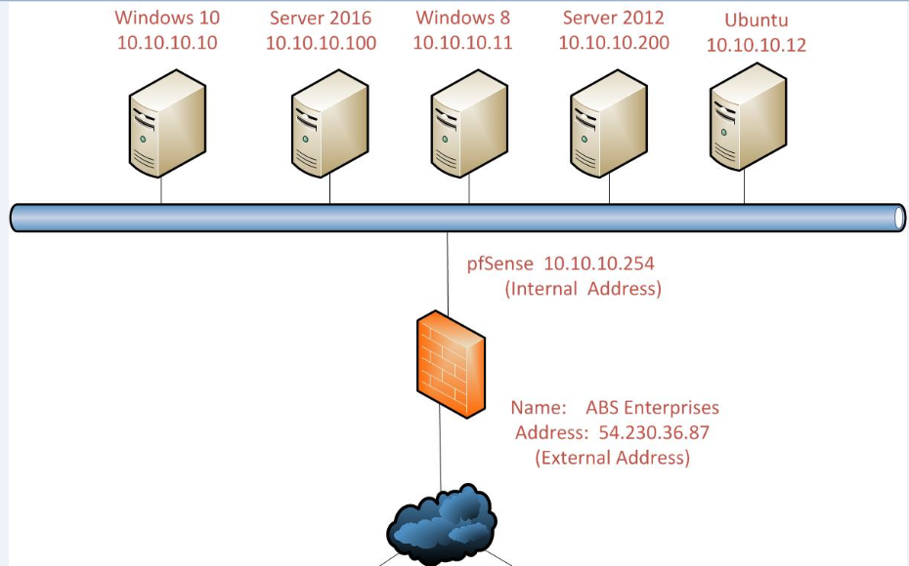

Justification

(Each section should contain the reasoning you present to justify the selection you made for your proposal. Look at it as your platform to tell finance and operations personnel why this should be selected for the network design)

B. Network Media

Note: (Choose wired or wireless) Be aware that your solution needs to include support for the selected media. For example, if you choose wireless, ensure you have wireless adapters for your desktops.

Business Needs

Assess the business needs.

Proposed Network Media (include network wiring diagrams)

Select one or more network media to use for this design.

Justification

Justify your determination that the selected media will meet the business needs.

C. Network Devices

Business Needs

Assess the business needs.

Proposed Network Devices

Select network devices to use to implement and support your design. Include setup and location information for the devices. Provide a comprehensive list of devices, including the quantity of each device needed.

Justification

Justify your determination that the selected network devices will meet the business needs.

Example: I selected a Cisco 2621 Router in order to connect the HR users to the rest of the company’s employees

D. Network Security Devices

Business Needs

Assess the business needs.

Proposed Network Security Devices

Select network security devices to use to secure the network. Include setup and location information for the devices. Provide a comprehensive list of devices, including the quantity of each device needed.

Justification

Justify your determination that the selected network security devices will meet the business needs.

Example: I selected a Cisco ASA 5510 Firewall in order to protect the company’s network.

E. Computer Systems

Business Needs

Assess the business needs.

Proposed Computer Systems

Select computer systems (servers) to use to implement the network design. Include setup and location information for the devices. Provide a comprehensive list of devices, including the quantity of each system needed.

Justification

Justify your determination that the selected systems will meet the business needs.

Example: I selected Windows 10 Professional for the operating system, because it is the newest, most secure, and stable version of Windows for end users.

Bibliography

Be sure to use references that are scholarly in nature and follow the formatting rules of the IEEE

